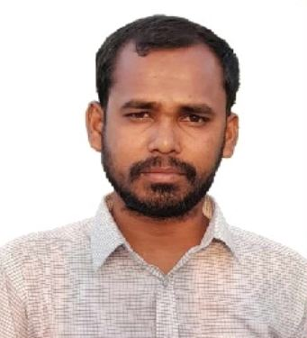Md. Faruk Hossain

6 year experience in the field of Estimate has developed me to work under pressure to deliver the best quality of service with utmost commitment.

[mdfarukhossain11071@gmail.com](mailto:mdfarukhossain11071@gmail.com)



**01756501854**

**H#63, Road#06, Block#F, Aftabnagar, Badda.**

# Work Experience



## Site Engineer

**Company:** Radiant property (pvt.) Ltd.

**Department:** Civil.

November 2018 – October 2023

− Estimating

− Visiting

− Billing

## Project Engineer

**Company:** Imperium Property Ltd.

**Department:** Civil.

November 2023 – Still Now

− Estimating

− Visiting

− Billing



# Education

### − Diploma in Civil Engineering

Pabna Textile Institute, Pabna

2018 2.76 out of 4.0

### − Secondary School Certificate (SSC)

Santhia Pilot High School, Pabna

2014 4.62 out of 5.0

## Interests

Quran, Travelling,



Reference

Md. Abu Saim

Radiant Property (pvt.) Ltd.

Phone: +8801891-153737

Date..................

……………… Signature

# Skills & Competences



Auto CAD Operating System

MS Office

Flexibility, Time- Management, Team Player

## Personal Information:

**Name :** Md. Faruk Hossain

**Father’s Name :** Md. Shahzan Khan

**Mother’s Name :** Most. Forida Khatun

**Date of Birth :** 31 dec, 1999

**Nationality :** Bangladeshi by born

**Religion :** Islam

**Sex :** Male

**Height :** 5′5″

**Marital Status :** Married

**Blood Group :** AB (+)

**Present Address :** Radiant property (pvt.) Ltd.

House-63, Block-F, Road-06, Aftabnagar, Badda, Dhaka

**Permanent Address :** Vill: Kalaichara, P.O:

Santhia, P.S: Santhia, Dist: Pabna.